Project- Canteen ordering system for unilever

Name- Fahad Tariq

Email- fhdtariq9@gmail.com

**Catering Industry**

# Stakeholders

| **ACTOR/Stakeholder** | **What they can do on the software created** |
| --- | --- |
| **Employees** | * Should be able Order Meal * Register for payroll deduction * Provide feedback |
| **Menu Manager** | * Create the menu * Update the menu. |
| **Canteen Manager** | * Request a delivery to the employees’ workstation. * View order placed. |
| **Meal deliverer** | * Deliver the lunch to the employee's desk * Able to mark order status after delivery |
| **Chef** | * Set up the food according to the request. * When food is Prepared pass to Canteen Manager so, he will assign it to delivery boy |
| **Payroll Department** | * Total number of dishes ordered by each employee * Deduct money from the employee’s salary |
| **Management** | * Download and view Reports as mentioned   + Which dishes are the most popular?   + How many employees are using the system?   + Satisfaction of the employees on using the system.   + Sales for each day   + Total monthly earnings |

# Problem Definition and Solution

* A lot of time is wasted by employees on going to the canteen to eat lunch
* Employees don’t get choice of food
* Time consumed in mobility and eating time in out to café
* Reduction of food wastage

# Advantages and Objectives

Advantages of the Canteen Ordering System:

* A system would save considerable time to those employees who use the service.
* It would increase the chance of them getting the food items they prefer.
* This would improve both their quality of work life and their productivity.
* The food wastage will be reduced.
* This will reduce the cost.

**Objectives:**

**Business Objective 1:**

Reduce canteen food wastage by a minimum of 30% within 6 months following first release.

Scale: Value of food thrown away each month by examining the canteen inventory

* Previous - 25% wasted
* Must plan for: Less than 15%

**Business Objective 2:**

Reduce canteen operating costs by 15% within 12 months, following initial release.

**Business Objective 3:**

Increase average effective work time by 30 minutes per employee per day, within 3 months.

**Business Objective 4:**

By making the ordering process automated and by delivering the food to the user's workstation, the canteen will be able to operate with lesser manpower.

# Existing System

* Time consuming, complex, manual, requires manpower , and a lot of food wastage.Below is the diag showing the current system
* 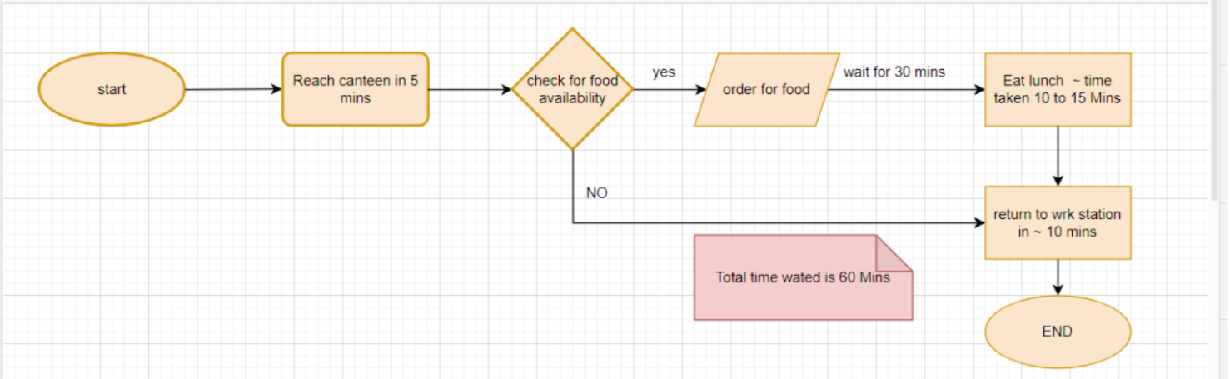

# Proposed System

The proposed system is a software system “Online ordering system” for tracking and ordering purposes.

| - **Pre-ordering**: Employees can place orders up to 12 hours in advance. |
| --- |
| - **Real-time Menu Updates**: Live updates on available food items and specials. |
| - **Delivery Scheduling**: Options for selecting delivery times within a specified window. |
| - **Payment Integration**: Secure payment options within the platform. |
| - **Feedback Mechanism**: Post-meal feedback and ratings for continuous improvement. |

# Scope using *use case diagram* (UML)

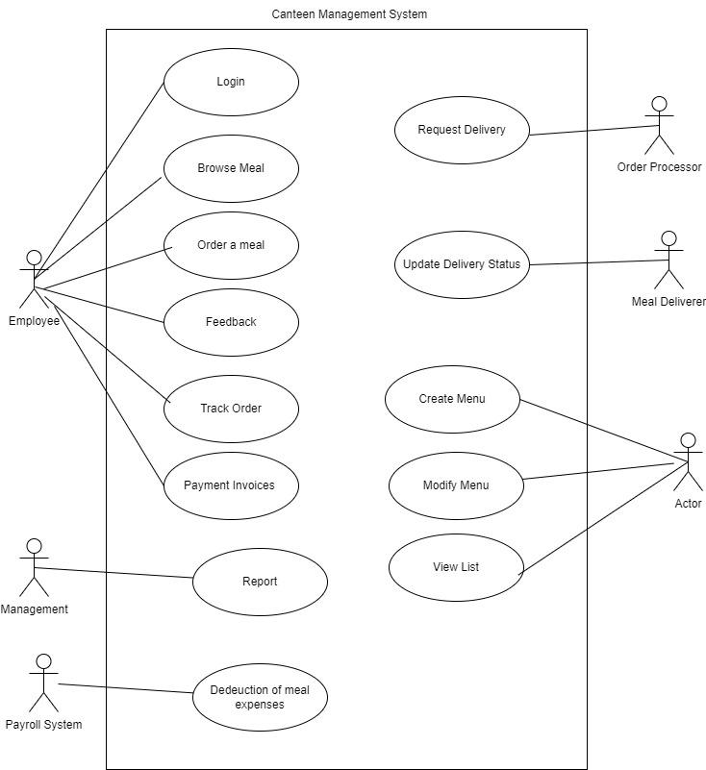

**Scope using *context diagram***

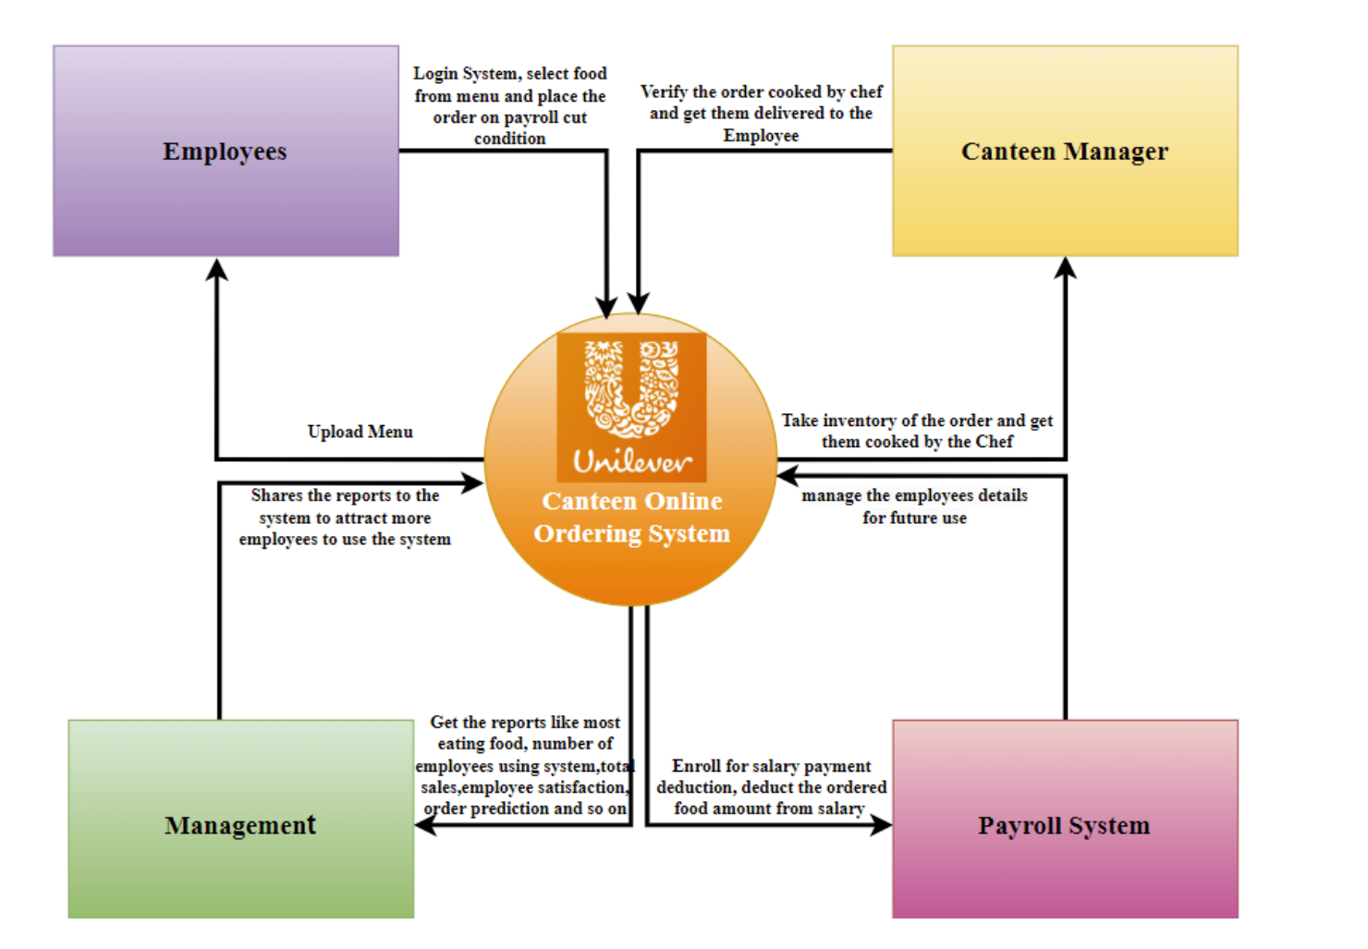

**In Scope**

* **Web-based ordering system** allowing employees to
  + Login
  + logout
  + View menus
  + Place orders
  + Receive food at their desks.
  + Pre order
  + View status
* **Menu management** by the canteen staff for daily updates.
* **Order processing** by the canteen manager, chef, and meal deliverer.
* **Feedback system** for employees to rate food and services.
* **Integration with payroll** to automatically deduct food payments from employee salaries.
* **Reporting** on dish popularity, sales, and employee satisfaction.

**Out of Scope**

* **Payment Gateway Integration**: Payment will be processed through payroll deductions rather than external payment systems.
* **Non-canteen food items** or external food delivery are not part of the system.
* **Dinner or breakfast** services (if not explicitly mentioned as a requirement).
* **Extensive customizations or meal preferences** beyond what is listed on the menu.
* **Mobile App** only website will be created as requested
* **Order** cannot be placed after 11 am

# Activity Diagram for the System:

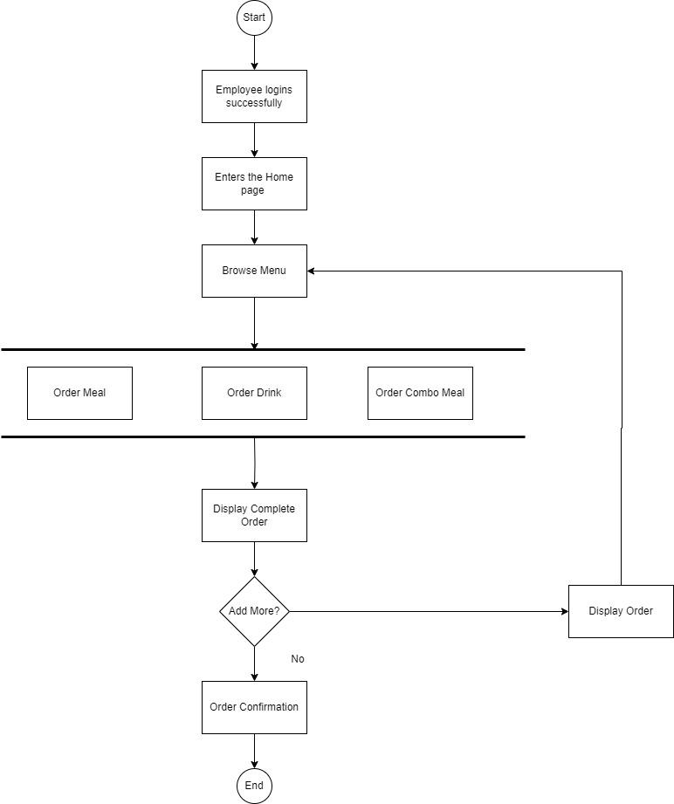

# Functional Requirements

* Menu Creation
* Menu Deletion
* Menu Editing/updation by menu manager
* Order creation by employee : Menu availability within office hours
* Order confirmation
* View Orders by order processor
* Meal delivery Closure in the system
* Feedback submission by employees
* Payroll deduction facility to be offered to users
* Payroll deduction calculations
* Reports generation
  1. Which dishes are the most popular?
  2. How many employees are using the system?
  3. Satisfaction of the employees on using the system. This should be tracked on the basis of feedback submitted by the employees.
  4. Sales for each day
  5. Total monthly earnings
  6. Order forecasting i.e. a prediction of which items will be ordered and when they will be ordered.

# Nonfunctional Requirements

* **System Requirement:**
  + Scalability and performance:
  + This canteen ordering system is required to support a volume of 1500 employees ordering. The web pages should be light and render fast.
* **Environments**
  + We are going to be creating and maintaining the program in Java. We chose Java because it will not change much over time, and if we make it well, there will be very little maintenance to be done on the code.
* **Usability:**
  + The screens should be self-explanatory and very user friendly. Management would not want employees not ordering from the system as they cannot understand the screens and data fields on screen.

# ER Diagram for the System:

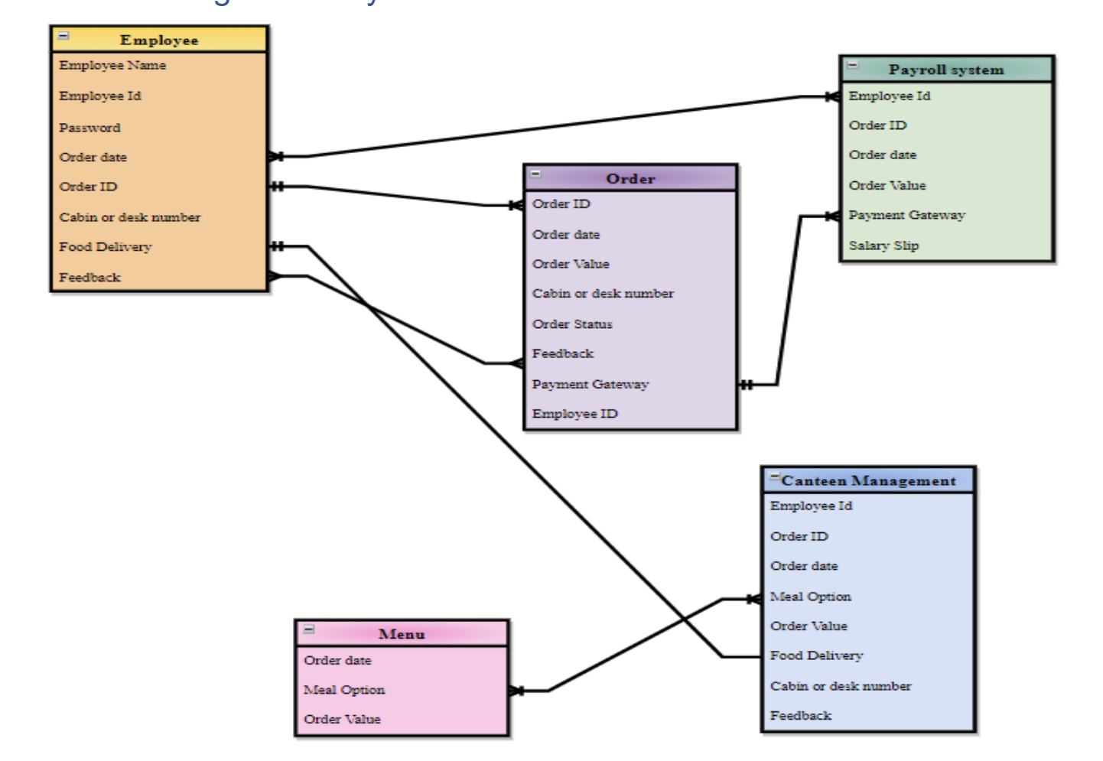

# Wireframe

